INCIDENCE OF MALARIA PARASITE AMONG PREGNANT WOMEN ATTENDING ANTENATAL CLINICS: A CASE STUDY OF GENERAL HOSPITAL, IKOT EKPENE, AKWA IBOM STATE.

BY
ENEFIOK INYANG
enefiok.inyang@fedpolyukana.edu.ng 08067584471

PEACE INYANG
peaceenefiokinyang@gmail.com 07064551515,
&
NAMSO ASUQUO EDET

DEPARTMENT OF STATISTICS, FEDERAL POLYTECHNIC, UKANA
AKWA IBOM STATE

ABSTRACT
This study analyzes reported cases of malaria among pregnant women, using a case study of patients attending antenatal services at the General Hospital, Ikot Ekpene, Akwa Ibom State. The aim is to examine whether the incidence of malaria infection in pregnancy is increasing or decreasing, as recorded in the hospital, and to provide descriptive insights for a better understanding of the trend. Antenatal services/clinics represent an essential healthcare intervention that supports scientific advancement, innovation, and sustainable economic development by reducing both prenatal and postnatal mortality. The dataset employed is secondary data extracted from hospital records spanning 2015 to 2024. Reported cases were compiled on a monthly basis and aggregated into quarters to enable the fitting of both monthly and quarterly models. The data were explored using charts such as bar charts and time plots, and analyzed with Time Series Analysis techniques. The results revealed that malaria incidence among pregnant women varied across months, quarters, and years, with a notably high incidence observed in the third quarter and lower incidence in the first quarter of each year. Reported cases were consistently low in December and January, while November recorded the highest incidence. The least squares model indicated a significant positive relationship between time (months) and reported cases, suggesting that incidence is on the rise. Forecasts for 2025 from both models confirmed this upward trend.
Keywords: Malaria, Pregnancy, Time Series Analysis, Antenatal Care, Trend Forecasting
GENERAL INTRODUCTION
Malaria, a parasitic infection transmitted by mosquitoes, is one of the most devastating infectious diseases, killing more than 1 million people annually. Pregnant women and children have the highest morbidity and mortality, and Africa bears the heaviest burden. The World Health Organization defines malaria as a disease of poverty caused by poverty. Pregnant women infected with malaria usually have more severe symptoms and outcomes, with higher rates of miscarriage, intrauterine demise, premature delivery, low-birth-weight, neonates and neonatal death. They are also at a higher risk for severe anemia and maternal death. Malaria, caused by parasites spread through mosquito bites, ranks among the most lethal infectious diseases, claiming over 1 million lives each year, with Africa suffering the greatest impact due to its widespread transmission and its high burden on vulnerable groups such as pregnant women, children, and individuals with weakened immune systems (Schantz-Dunn et al., 2009).
Malaria in pregnancy also contributes to significant perinatal morbidity and mortality. Infection is known to cause higher rates of miscarriage, intrauterine demise, premature delivery, low-birth-weight neonates, and neonatal death. As funding increases to combat both malaria and maternal mortality, understanding how malaria specifically affects pregnant women is crucial in our efforts to improve maternal and perinatal health and curb the spread of this preventable infectious disease.
Malaria is the second most common cause of infectious disease-related death in the world, after tuberculosis. It is estimated to affect between 350 to 500 million people annually and accounts for 1 to 3 million deaths per year (Centers for Disease Control and Prevention $\left[CDCP\right]$,2009) and Global Fund Web Site $\left[GFWS\right]$, 2009) Sub-Saharan Africa has the largest burden of malarial disease, with over 90% of the world’s malaria-related deaths occurring in this region. Twenty-five million pregnant women are currently at risk for malaria, and, according to the World Health Organization (WHO), malaria accounts for over 10,000 maternal and 200,000 neonatal deaths per year (World Health Organization $\left[WHO\right],$2009)
Malaria is transmitted when an infected mosquito takes a human blood meal and the Plasmodium sporozoites are transferred from the saliva of the mosquito into the capillary bed of the host. Within hours, the parasite will migrate to the liver, where it undergoes further cycling and replication before being released back into the host’s bloodstream. The incubation period, from the time of mosquito bite until clinical symptoms appear, is typically 7 to 30 days. Symptoms include fever, headache, nausea, vomiting, and myalgias. Due to the cycling parasitemia in the bloodstream, patients will often experience symptoms every 2 to 3 days, depending on the type of Plasmodium with which they are infected.
More recent advances in diagnosis have been made with the introduction of rapid diagnostic tests (RDTs), immunochromatographic dipstick assays that act in a similar fashion to a home pregnancy test. Most of the RDTs report sensitivities above 90% for detection of malaria, with increasing sensitivity as the level of parasitemia increases. It is hypothesized that malarial antigen detection via RDTs may be a better diagnostic tool for use in pregnant women, as much of P falciparum sequesters in the placenta and therefore may not be visible on a standard smear, producing false-negative results if diagnosis is based on microscopy and clinical symptoms alone (Murray and Bennet, 2009). Malaria can be prevented with appropriate drugs, bed nets treated with insecticide, and effective educational outreach programs.
Different authors have different views on malaria Infected pregnant women face severe health complications, including low birth weight, premature labor, and neonatal mortality. In 2022, global estimates indicated 249 million malaria cases and 608,000 deaths, with Africa accounting for 94% of cases and 95% of deaths (WHO, 2023).
In sub-Saharan Africa, malaria remains a significant public health concern, with the most prevalent causative agent, Plasmodium falciparum, leading to adverse health outcomes, particularly in pregnant women and young children (Nduka et al., 2006).
In the absence of targeted interventions, around 45% of pregnant women in Africa are likely to experience malaria, with nearly half developing placental malaria (Walker et al., 2014). Pregnancy-related malaria contributes to numerous adverse outcomes such as infant anaemia, intrauterine growth restriction, preterm delivery, and stillbirth (Rogerson et al., 2018).
Studies show that malaria prevention during pregnancy significantly reduces the risk of low birth weight and neonatal death (Eisele et al., 2012 and McClure et al., 2013). However, the specific mechanisms through which malaria during pregnancy affects fetal and infant health remain unclear (Malhotra et al., 2009. Increasing evidence suggests that maternal malaria may influence fetal immune responses, potentially increasing the infant's susceptibility to malaria in early childhood (Tassi et al., 2013 and Gonçalves et al., 2014). The impact of malaria during pregnancy on children’s health is critical for developing effective interventions to reduce early childhood morbidity and mortality (Borgella et al., 2013 and Asante et al., 2013).
Abu et al (2025) examined factors associated with malaria in pregnancy among women attending ANC clinics in selected districts of the Ashanti Region, Ghana. A cross-sectional study was conducted among 1215 pregnant women selected through multi-stage sampling. Data were collected using structured questionnaires and analyzed using descriptive and inferential statistics, including regression analysis and concluded that age, education, marital status, income, religion and insecticide-treated bed net (ITN) use significantly influence malaria prevalence in pregnancy.
Each year, approximately 50 million women become pregnant in malaria endemic regions.
Prevention of malarial disease in pregnancy relies on 2 main strategies: providing pregnant women with insecticide-treated bed nets (ITN) and intermittent presumptive treatment (IPT) with antimalarial medications. IPT refers to the administration of 2 or more doses of chemoprophylaxis after 20 weeks of gestation in an attempt to reduce subclinical malarial load.
Although the WHO currently recommends that all pregnant women living in malaria-endemic regions use insecticide-treated bed nets and IPTp-SP (intermittent presumptive treatment in pregnancy with at least 2 doses of sulfadoxine-pyrimethamine), studies show poor uptake of both preventative efforts among pregnant women. A recent survey among postpartum women in rural Uganda, in which 88% had made more than 1 prenatal visit, found that only 31% of women used a bed net during pregnancy and only 36% had received 2 doses of IPTp- SP (Kiwuwa & Mufubenga, 2008) This indicates that as access to and utilization of antepartum care increase, there is still a role for improved administration of IPTp-SP and education regarding bed net use.
Bardoe et al (2024) reviewed 36 studies from 1994 to 2019 showed that malaria prevalence decreased in various regions, such as the northern savannah zone, where seasonal transmission fell from 50–60% to 13–26% by 2019. This reduction is likely due to malaria control measures, although seasonal transmission persists due to environmental factors. In the middle transitional/forest zone, perennial malaria transmission decreased from 60% in the late 1990s to about 5–20% by 2018, highlighting the need for tailored interventions addressing both seasonal and perennial risks. The coastal savannah zone saw a decrease from 28–35% to 5–11% by 2018–2019, reflecting progress in malaria control. Despite these improvements, malaria remains a challenge due to factors like healthcare access, socio-economic conditions, and cultural practices. In the Bono East Region of Ghana, a multicentre hospital-based mixed-method cross-sectional study reported a prevalence rate of 10.8% (95% CI 9.32–12.56) for malaria among pregnant women.
Treatment of uncomplicated malaria in pregnancy is a balance between potential fetal adverse effects from drug toxicity and improved clinical status with clearance of the parasite. In 2006, the WHO recommended a combination of quinine and clindamycin for treatment of uncomplicated malaria in pregnancy; however, there is a risk of hypoglycemia with quinine use, as well as increasingly drug-resistant P falciparum. More data currently support the use of artemisinin-based combination therapy, which appears safe and effective in pregnancy (Orton & Omari, 2008). For severe malaria in pregnancy, the WHO currently recommends treatment with either intravenous (IV) quinine or artesunate, or IV artesunate in the second and third trimesters. Not only should IV quinine be avoided in the second and third trimesters as it is associated with recurrent hypoglycemia, but evidence supports the superiority of artesunate over quinine in the nonpregnant patient. In epidemic situations, if IV or intramuscular medication is unavailable, patients should receive artesunate suppositories and be transferred to a higher level facility (WHO, 2006).
Nigeria has made considerable progress in the fight against malaria and remains one of the leaders in the testing and large-scale application of new recommendations and innovative strategies. These different strategies have led to significant progress in the fight against malaria. However, malaria remains a public health problem in Nigeria, with an uneven distribution across the different regions. Although malaria in pregnancy might be asymptomatic due to the high level of acquired immunity in multigravida mothers residing in high-transmission areas, it can be associated with maternal anemia, abortion, preterm birth, and low birth weight (Menéndez et al. 2008)

In view of the harmful effect of malaria on pregnancy women and the dangers to the unborn children, it becomes necessary to collect data and check variation in the number of pregnancy women reported to be suffering from malaria parasite, examine the trend of pregnancy women receiving antenatal care services at General Hospital, Ikot Ekpene to ascertain if the incidence is on the decrease. This work will be very vital to researchers in the field of Health Sciences and in Institutions of higher learning who might desire to under- take some studies on the menace of malaria parasite with respect to pregnant women. The work will also be of significance to policy holders who may explore other means of eradicating the menace.
RESEARCH DESIGN AND METHODOLOGY
This study focused on the analysis of the reported cases of malaria with respect to pregnancy women. A case study of women attending antenatal services at the General Hospital Ikot Ekpene, Akwa Ibom State. The essence is to examine whether the incidence of malaria infection with respect to pregnancy is increasing or decreasing as reported in the Hospital and to obtain other descriptive information for a better understanding of the trend pattern. The data set used in this study is a secondary data extracted from the Hospital records in the Hospital from 2015 to 2024. The reported cases were extracted in monthly basis and was also was pooled with respect to quarters for the fitting of monthly and quarterly models. The dataset was explored using charts like bar charts and time plots and was analyzed using Time Series Analysis Techniques. The population of the study is the reported cases of all malaria cases relating to pregnancy women in the Hospital right from the time the Hospital commenced antenatal services. A non- probability sampling technique (convenience sampling) was applied in selecting the needed sample from the target population. The sample for this study is the reported cases of all malaria cases relating to pregnancy women in the Hospital from 2015 to 2024. The sample size for this was 120 months. Data were extracted on monthly and quarterly bases and were presented in a tabular form for easy analysis and understanding.
Data Analysis Technique and Presentation
The techniques used in this study are descriptive statistics and time series analysis. A time series model is an algebraic representation of the relationship among its components. They are basically three models used in time series, namely; Additive Model (Y_{t} = T_{t} + S_{t} + C_{t} + I_{t}), Multiplicative Model (Y_{t} = T_{t} x S_{t} x C_{t} x I_{t}) and mixed Model (Y_{t} = T_{t} x S_{t} x Z_{t})
Y_{t} = Actual value observed over time, t. T_{t}= Trend component S_{t}=Seasonal movement
C_{t} = Cyclical movement I_{t} =Irregular movement and Zt =C_{t} + I_{t}
Time series trend can be modeled as a linear function when original data suggest that a given time series tend to increase or decrease at a constant rate. Hence, the series can be best described by a polynomial of order I or straight-line equation. The least squares model is stated thus: Y = + X_{i} + , where Y = dependent variable (reported cases),
X_{i} = Independent variable (time), = Constant (Intercept),
= Slope (rate of change in Y as a result of a unit change in X), =Random error
The fitted model becomes
DATA ANALYSIS, RESULTS AND INTERPRETATION
Data Visualization
Monthly Descriptive Statistics
Table 1 Monthly Descriptive Statistics
 | N | Min | Max | Sum | Mean |  | Std. Dev | Var
 |  |  |  |  |  | Std. Error
REPORTED CASES MONTHS | 120 | 7 | 46 | 3033 | 25.275 | .89113 | 9.76184 | 95.293
Valid N (listwise) | 120

Table 1 above, a total of 120 months were considered and minimum of 7 pregnancy women and a maximum of 46 pregnancy women tested positive to malaria parasite on monthly basis from 2015 to 2024, mean and standard deviation were 25.275 and 9.762 respectively.
Quarterly Descriptive Statistics
Table 2: Quarterly Descriptive Statistics
 | N | Min | Max | Sum | Mean |  | Std. Dev | Var
 |  |  |  |  |  | Std. Error
REPORTED CASES QUARTERS | 40 | 30 | 110 | 3033 | 75.8250 | 3.21732 | 20.34811 | 414.046
Table 2 above, a total of 40 months were considered and minimum of 30 pregnant women and a maximum of 110 pregnant women tested positive to malaria parasite on monthly basis from 2015 to 2024, mean and standard deviation were 75.83 and 20.348 respectively.
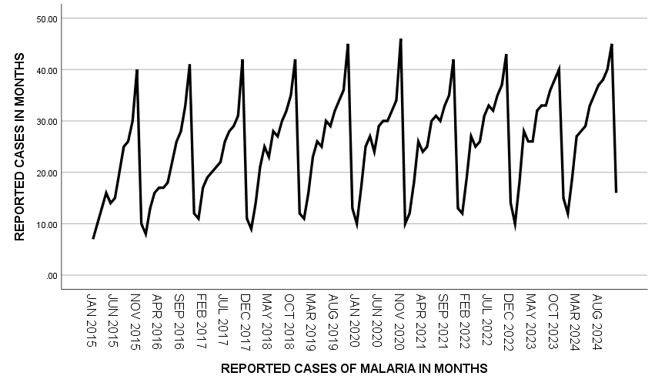
Figure 1: Timeplot for the monthly reported cases of pregnancy women affected by malaria parasite.
Figure 1 shows that the reported cases vary from month to month and from years to years
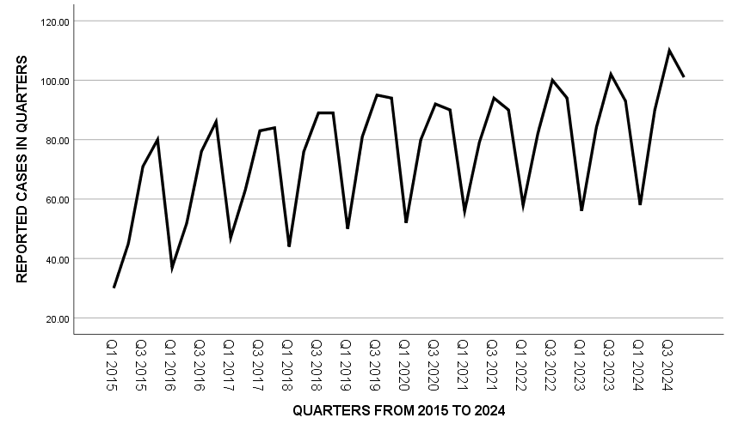
Figure 2: Timeplot for the quarterly reported cases of pregnancy women affected by malaria parasite.

Figure 2 shows that the reported cases vary from quarter to quarter and from years to years with very high incidence at the third quarter with a lower incidence in the first quarters of every year.
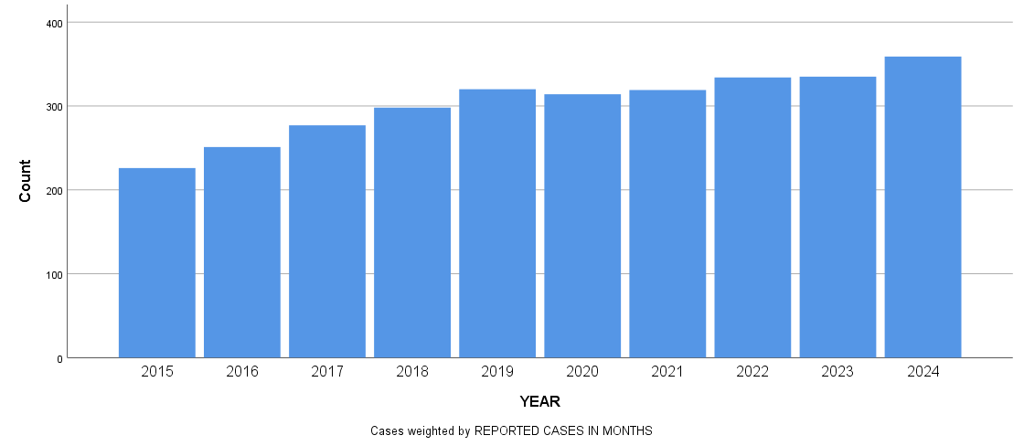
Figure 3 : Simple Bar Chart showing yearly reported cases of pregnancy women affected by malaria parasite.

From figure 3, the reported cases appear to be on a gradual increase from 2015 to 2024.
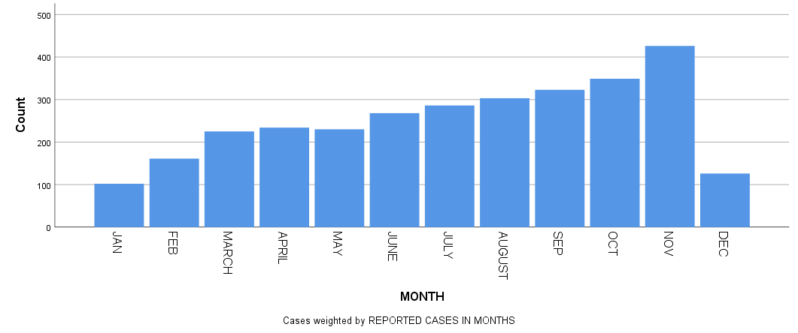
Figure 4 : Simple Bar Chart showing monthly reported cases of pregnancy women affected by malaria parasite.

From figure 4, the reported cases are very low in the months of December and January with the highest incidence recorded in the month of November.
Data Analysis
Data were analyzed using a Statistical Package for Social Sciences (SPSS) Version 25.0.
Estimation Least Squares Parameters
The Least Squares Parameters (Coefficients) for Monthly and quarterly Cases were obtained.
Table 3: Least Squares Parameters (Coefficients) for Monthly Cases
Model |  | Unstandardized Coefficients |  | Standardized Coefficients | t | Sig.
 |  | B | Std. Error | Beta | t | Sig.
1 | (Constant) | 19.031 | 1.675 |  | 11.363 | .000
1 | Reported | .103 | .024 | .368 | 4.296 | .000
a. Dependent Variable: Reported Cases

Table 3 above shows the least squares coefficients for the monthly reported cases of pregnant women tested positive to malaria parasite. The model is given as ${\hat{Y}}_{t}=19.031+0.103X_{t}$

Table 5: Fitness of the model for Monthly Cases
Model |  | Sum of Squares | df | Mean Square | F | Sig.
1 | Regression | 1533.886 | 1 | 1533.886 | 18.458 | .000^{b}
1 | Residual | 9806.039 | 118 | 83.102
1 | Total | 11339.925 | 119
Table 5 reflect the test of adequacy of the estimated equation or model for the monthly incidence of malaria in pregnant women.
Table 6: Least Squares Parameters (Coefficients) for Quarterly Cases
Model |  | Unstandardized Coefficients |  | Standardized Coefficients | t | Sig.
 |  | B | Std. Error | Beta | t | Sig.
1 | (Constant) | 56.735 | 5.612 |  | 10.109 | .000
1 | Reported | .931 | .239 | .535 | 3.904 | .000
  - Dependent Variable: Reported cases

Table 6 above shows the least squares coefficients for the quarterly reported cases of pregnant women tested positive to malaria parasite. The model is given as: ${\hat{Y}}_{t}=56.735+0.931X_{t}$
Table 8: Fitness of the Model for quarterly Cases
Model |  | Sum of Squares | df | Mean Square | F | Sig.
1 | Regression | 4622.201 | 1 | 4622.201 | 15.239 | .000^{b}
1 | Residual | 11525.574 | 38 | 303.305
1 | Total | 16147.775 | 39
Table 8 reflect the test of adequacy of the estimated equation or model for the monthly incidence of malaria in pregnant women.
FORECASTING
The forecasts for both models are presented in Table 9 below.
Table 9: Forecast for 2025
MONTH | $$X_{t}$$ | $${\hat{Y}}_{t}=19.031+0.103X_{t}$$ | Quarter | $$X_{t}$$ | $${\hat{Y}}_{t}=56.735+0.931X_{t}$$
Jan | 121 | 31.49 | Q1 | 41 | 94.91
Feb | 122 | 31.59 | Q2 | 42 | 95.84
Mar | 123 | 31.70 | Q3 | 43 | 96.77
Apr | 124 | 31.80 | Q4 | 44 | 97.70
May | 125 | 31.91
Jun | 126 | 32.01
Jul | 127 | 32.11
Aug | 128 | 32.22
Sep | 129 | 32.32
Oct | 130 | 32.42
Nov | 131 | 32.52
Dec | 132 | 32.63

Interpretation of Results
Based on the results of the analysis, the following interpretations were made:
- The descriptives statistics in Table 1 and Table 2 revealed that a minimum of 7 and a maximum of 46 pregnant women who tested positive to malaria parasite were recorded on monthly basis while a minimum of 30 and a maximum of 110 pregnant women who tested positive to malaria parasite were recorded on quarterly basis. The mean reported cases for monthly and quarterly malaria cases for pregnant women were 25 and 76 respectively. This implies that there exist cases in every month and every quarter and that the tendency for a pregnant woman to suffer from malaria parasite there.
- Figure 1and Figure 2 show that the reported cases of malaria vary from month to month, quarter to quarter and from years to years. A very high incidence of malaria in pregnant women was noticed at the third quarter with a lower incidence in the first quarters of every year. This implies that the incidence of malaria is somehow linked to seasons especially in the rainy seasons.
- From figure 3, the reported cases appear to be on a gradual increase from 2015 to 2024 which implies that the reported cases are on the increase. From figure 4, the reported cases are very low in the months of December and January with the highest incidence recorded in the month of November. This also confirm that malaria parasite is more predominant in the rainy season when compared to the dry season.
- The fitted model for monthly reported cases is given as ${\hat{Y}}_{t}=19.031+0.103X_{t}$. This implies that, the incidence of malaria parasite on pregnant women is increasing at the rate of 0.103 per month while about 19 pregnant women are constant. The fitted model was adequate since the p-value in the ANOVA table was less than the significance level of 0.05. Hence, there exist a significant positive relationship between the months and the reported cases of malaria parasite on pregnant women.
- The fitted model for quarterly reported cases is given as ${\hat{Y}}_{t}=56.735+0.931X_{t}$. This implies that, the incidence of malaria parasite on pregnant women is increasing at the rate of 0.931 per month while about 57 pregnant women are constant. The fitted model was adequate since the p-value in the ANOVA table was less than the significance level of 0.05. Hence, there exist a significant positive relationship between the quarters and the reported cases of malaria parasite on pregnant women.
- The forecasts for 2025 for both models showed that as far as pregnancy and malaria parasite is concern, the incidence for 2025 will still be on the increase.
SUMMARY AND CONCLUSION
Discussion of Findings
This study focused on the analysis of the reported cases of malaria with respect to pregnancy women. A case study of women attending antenatal services at the General Hospital Ikot Ekpene, Akwa Ibom State. The essence is to examine whether the incidence of malaria infection with respect to pregnancy is increasing or decreasing as reported in the Hospital and to obtain other descriptive information for a better understanding of the trend pattern. The data set used in this study is a secondary data extracted from the Hospital records in the Hospital from 2015 to 2024. The reported cases were extracted in monthly basis and was also was pooled with respect to quarters for the fitting of monthly and quarterly models. The dataset was explored using charts like bar charts and time plots and was analyzed using Time Series Analysis Techniques. The descriptives statistics in Table 1 and Table 2 revealed that a minimum of 7 and a maximum of 46 pregnant women who tested positive to malaria parasite were recorded on monthly basis while a minimum of 30 and a maximum of 110 pregnant women who tested positive to malaria parasite were recorded on quarterly basis. The mean reported cases for monthly and quarterly malaria cases for pregnant women were 25 and 76 respectively. This implies that there exist cases in every month and every quarter and that the tendency for a pregnant woman to suffer from malaria parasite there. The results of the analysis revealed that the reported cases of malaria vary from month to month, quarter to quarter and from years to years with a very high incidence of malaria in pregnant women noticed in the third quarter with a lower incidence in the first quarters of every year. This implies that the incidence of malaria is somehow linked to seasons especially in the rainy seasons. The reported cases are very low in the months of December and January with the highest incidence recorded in the month of November. This also confirm that malaria parasite is more predominant in the rainy season when compared to the dry season. This is in conformity with the work of Bardoe et al. (2024) who reviewed 36 studies from 1994 to 2019 concluded that malaria prevalence decreased in various regions, such as the northern savannah zone, where seasonal transmission fell from 50–60% to 13–26% by 2019.
The fitted model for monthly reported cases revealed a direct relationship. Hence, there exist a significant positive relationship between the months and the reported cases of malaria parasite on pregnant women. Also, the fitted model for quarterly reported cases indicates an increasing rate which conclude that there exists a significant positive relationship between the quarters and the reported cases of malaria parasite on pregnant women. This is inline with the works of Tassi et al (2013) and Gonçalves et al (2014) who stated that the increasing evidence maternal malaria, may influence fetal immune responses, potentially increasing the infant's susceptibility to malaria in early childhood.
The forecasts for 2025 for both models showed that as far as pregnancy and malaria parasite is concern, the incidence for 2025 was still on the increase. This if left on attended to, may cause serious wastage of time, energy and resources and even life and in future will not guarantee sustainable growth and development.
Summary of Findings
From the result of the analysis, the study is summarized thus:
- The reported cases of malaria parasite among pregnant women vary from month to month, quarter to quarter and from years to years.
- A very high incidence of malaria in pregnant women was noticed at the third quarter with a lower incidence in the first quarters of every year.
- The reported cases are very low in the months of December and January with the highest incidence recorded in the month of November.
- There exists a significant positive relationship between the time (months or quarters) and the reported cases of malaria parasite on pregnant women.
- The forecasts for 2025 for both models are also on the increase.
Conclusion
There exists an upward trend in the reported cases of malaria among women attending antenatal clinics at General Hospital. Ikot Ekpene and that incidence of malaria among these women are more predominant in the months of October and November.

Recommendation
(i) The study recommends that government and individuals should continue to invest more in the health care system for the benefit of the pregnant women in particular and the public in general.
(ii) Couples intending to enter this way should first treat malaria and other associated infections in order not to posed problem for the unborn child and safeguard the mother as well.
( iii) The efficacy of some of the malaria drugs should be seriously investigated.

REFERENCES
Abu, B. E, Petra, A. O, Emmanuel, A. K., Stephen, A., Akua, G. S and Elsie, F. K. (2025).
Factors associated with malaria in pregnancy among women attending ANC clinics in selected districts of the Ashanti Region, Ghana Malaria Journal volume 24,

Asante, K.P, Owusu-Agyei S, Cairns M, (2013). Placental Malaria and the Risk of Malaria in
Infants in a high Malaria Transmission area in Ghana: A prospective cohort study. J
Infect Dis. 208:1504–13.

Bardoe D, Bio R.B, Yar D.D, Hayford D. (2024). Assessing the prevalence, risk factors, and
socio-demographic predictors of malaria among pregnant women in the Bono East Region of Ghana: a multicentre hospital-based mixed-method cross-sectional study. Malar J. 23:302.

Borgella, S, Fievet, N, Huynh, B.T, Ibitokou, S, Hounguevou, G, Affedjou, J, (2013). Impact
of pregnancy-associated malaria on infant malaria infection in southern Benin. PLoS ONE. 8(11): e80624.

Centers for Disease Control and Prevention Web site, authors. (2009). Malaria facts.
http://www.cdc.gov/malaria/facts.htm.

Eisele, T.P, Larsen, D.A, Anglewicz, P.A, Keating, J, Yukich, J, Bennett, A. (2012). Malaria
Prevention in pregnancy, birthweight, and neonatal mortality: a meta-analysis of 32 National cross-sectional datasets in Africa. Lancet Infect Dis.12(12):942–9.

Gonçalves, B.P, Huang. C.Y, Morrison. R, Holte. S, Kabyemela. E, Prevots. D.R, (2014).
Parasite burden and severity of malaria in Tanzanian children. N Engl J Med.370(19):1799–808.

Kiwuwa, M.S, Mufubenga, P. (2008). Use of antenatal care, maternity services, intermittent
Presumptive treatment and insecticide treated bed nets by pregnant women in Luwero district, Uganda. Malar J. 7:44. doi: 10.1186/1475-2875-7-44.

Malhotra, I, Dent, A, Mungai, P, Wamachi, A, Ouma, J, H, Narum, D.L, (2009). Can prenatal
Malaria exposure produce an immune tolerant phenotype? A prospective birth cohort study in Kenya. PLoS Med. 6(7): e1000116.

McClure, E.M, Goldenberg, R.L, Dent, A.E, Meshnick, S.R. (2013). A systematic review of the
impact of malaria prevention in pregnancy on low birth weight and maternal anemia. Int J Gynaecol Obstet.121:103–9.

Menéndez, C, Romagosa, C, Ismail, M.R, (2008). An Autopsy study of maternal mortality in
Mozambique: the contribution of infectious diseases. PLoS Med. 5: e44. doi: 10.1371/journal.pmed.0050044.

Murray, C.K, Bennet, J.W. (2009). Rapid Diagnosis of Malaria. Interdiscip Perspect Infect Dis.
2009; 2009:415953. doi: 10.1155/2009/415953.

Nduka, F.O, Egbu, A, Okafor, C, Nwaugo, C.O. (2006). Prevalence of Malaria Parasites and
Anaemia in pregnant and non-pregnant women in Aba and Okigwe towns of southeast Nigeria. Animal Res Int. 3:508–12.

Orton, L.C, Omari, A.A. (2008). Drugs for treating uncomplicated malaria in pregnant women.
Cochrane Database Syst Rev.4 doi: 10.1002/14651858.CD004912.pub3. CD004912.

Rogerson, S.J, Desai, M, Mayor, A, Sicuri, E, Taylor, S.M, Van, E.A.M. (2018). Burden,
Pathology, and costs of malaria in pregnancy: new developments for an old problem. Lancet Infect Dis.18: e107–18.

Schantz-Dunn, J, Nour, N.M. (2009). Malaria and pregnancy: a global health perspective. Rev Obstet
Gynecol. 2:186–92.

Tassi, Y. S, Fouda, G.G, Sama, G, Ngu, J.B, Leke, R.G.F, Taylor, D.W. (2013). Increased
Susceptibility to Plasmodium falciparum in infants is associated with low, not high,
placental malaria parasitemia. Sci Rep. 2018; 8:169.

Walker, P.G, Ter, k. F.O, Garske, T, Menendez, C, Ghani, A.C. (2014). Estimated risk of
Placental infection and low birthweight attributable to Plasmodium falciparum malaria in Africa in 2010: a modelling study. Lancet Glob Health. 2014;2: e460–7.

White, N.J, Breman, J.G, (2008). Malaria. In: Fauci AS, Braunwald E, Kasper DL,editors.
Harrison’s Principles of Internal Medicine. 17th ed. New York: McGraw-Hill; 2008. pp. 1280–1293.

World Health Organization (2023). Malaria [Internet]. Available from:
https://www.who.int/news-room/fact-sheets/detail/malaria

World Health Organization Web site, authors (2009). Global Malaria Programme: Pregnant
women and infants. http://apps.who.int/malaria/pregnantwomenandinfants.html.

World Health Organization, authors. (2006) Guidelines for the Treatment of Malaria. Geneva:

